1. **System Analysis Modeling**
   1. **Feasibility Study:-**

* **What is the feasibility?**

A feasibility study performed by a company when they want to know whether a project is possible given certain circumstances to find out whether a company has enough money for a project, to find out whether the product being created will sell, or to see if there are enough human resources for the project.

* **Here we have to discuss the following feasibilities:-**

1. Technical feasibility
2. Cost feasibility
3. Time feasibility
4. **Technical Feasibility:-**

* The application uses minimum system requirement that is available today in almost ever android smartphones.
* The technical analysis evaluates the technical merits of the system at the same time collecting additional information about performance, reliability, maintainability, and productivity so by this we can say that application is technically feasible.
* This system requires minimum 512MB RAM and 80MB of free storage space available which nowadays easily available in most of the phones.

1. **Cost Feasibility:-**

* The feasibility study will examine the economic costs related to the project, including equipment or other resources, man-hours, the proposed benefits of the project, the break-even schedule for the project, the financial risks associated with the proposal.
* Among the most important information contained in the feasibility study is the cost-benefit analysis. That is an assessment of economics justification for a chatbot-based application.
* System developed by us cheaper as compared to resources needed. This is because most of the resources we were used are open-source and freeware.
* For this project, we have calculated all around cost including all resources, development time, Efforts, etc… of about ₹55,000.

1. **Time Feasibility:-**

* A time feasibility study will take into account the period in which the project is going to take up to its completion. A project will fail if it takes too long to be completed before it is useful.
* In our project, the estimated LOC is 9000(9KLOC). And our project is made with a smaller development team. So the best COCOMO Model estimation technique we found was organic.
* For organic cost estimation, we have to find out the effort first.

Effort = 2.4(KLOC)^1.05 PM

Effort = 2.4(9)^1.05 PM

Effort = 2.4 * 10.0451086 PM

**Effort = 24.1082606 PM**

* Now the formula for Time is:

TDev = 2.5(Effort)^0.38 Months

TDev = 2.5(24.1082606)^0.38 Months

TDev = 2.5 * 3.35137506 Months

TDev = 8.37843765 Months

**TDev = ~ 8 Months**

* So the development time we estimated was 8 Months.
  1. **User-Based Modeling:-**

**Use Case Diagram:-**

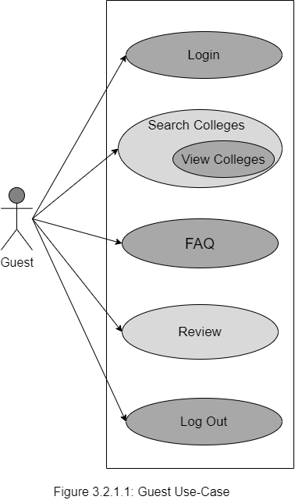**1. Guest Use-case :**

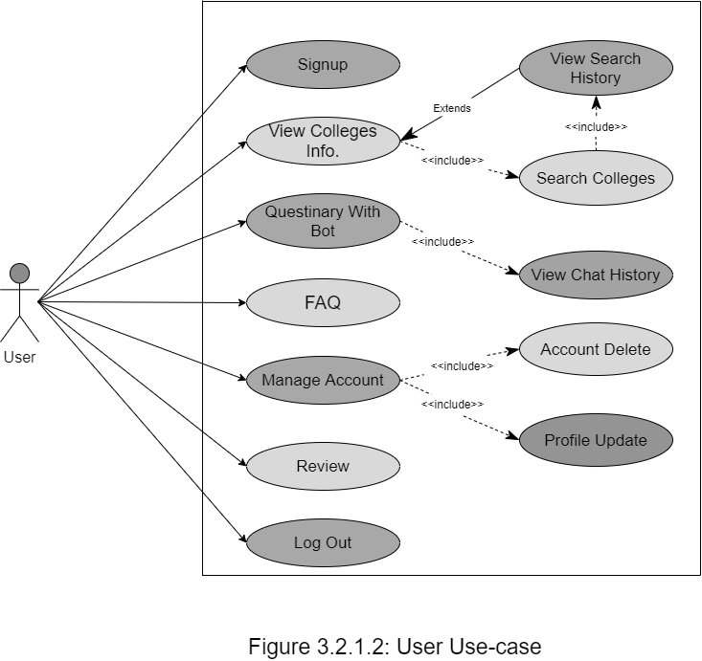**2. User Use-case :**

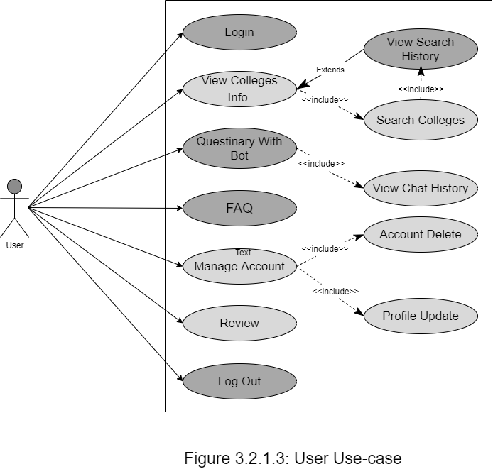**2. User Use-case :**

**3. Admin Use-Case :**